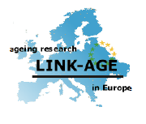
LINK-AGE Working Research Groups and 2009 annual meeting

Radisson Hotel in Brussels Belgium

November 29- December 01 2009

Abstract Submission Form

Please return by e-mail to:
Dr. Béatrice Rayet

Deadline: September 30, 2009
LINK-AGE Deputy Coordinator
University of Namur
beatrice.rayet@fundp.ac.be

Type or paste Abstract Here

Participant information

Last Name:

First Name:

Institution:

Country:

e-mail:

Link-Age member status (Full- Associate):

